**LEASE MANAGEMENT**

**Team Members:**

* ANNAL G
* JEENESH S
* NITHISH M
* JAINESH MM

**Project Overview:**

This project aims to develop a comprehensive lease management system using Salesforce. The system will streamline the process of managing lease agreements, tracking tenant information, scheduling maintenance, and generating reports. By leveraging Salesforce's robust platform, the system will provide a user-friendly and efficient tool for property managers to handle their leasing operations effectively

**Objective:**

* To create a centralized platform for managing lease agreements and tenant information.
* To automate maintenance scheduling and ensure timely completion of tasks.
* To generate insightful reports for better decision-making.
* To enhance user experience with an intuitive interface and seamless functionality

**Schedule Apex class:**

**Create Property Object:**

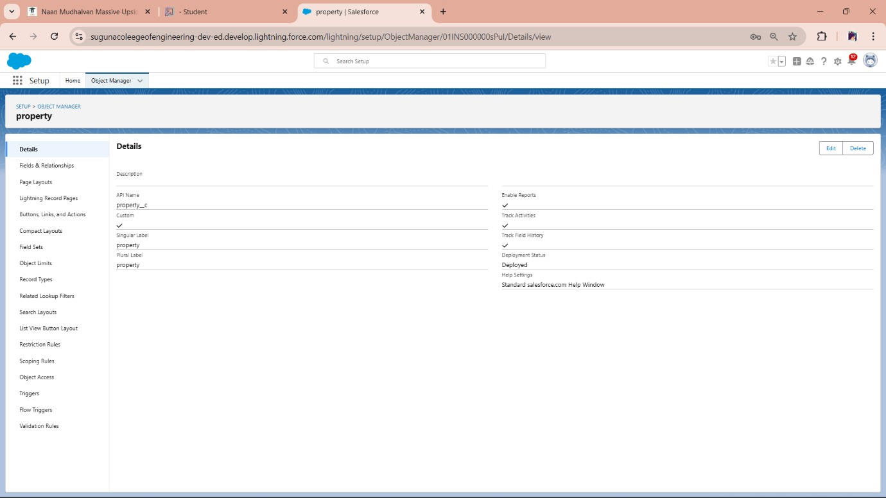

**Create Tenant Object:**

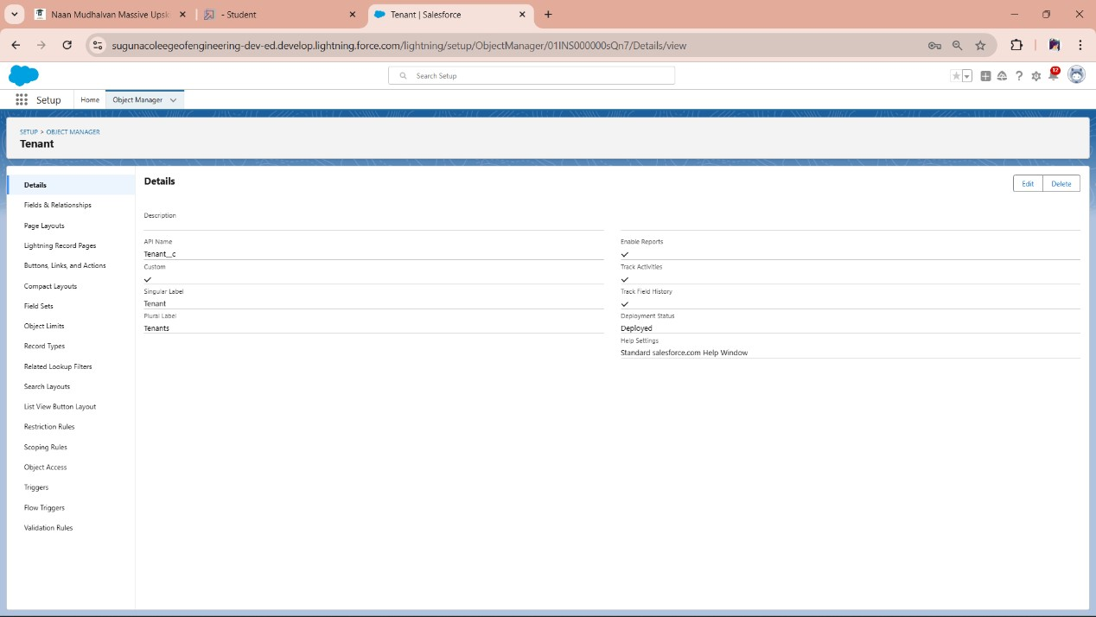

# Create Payment Object

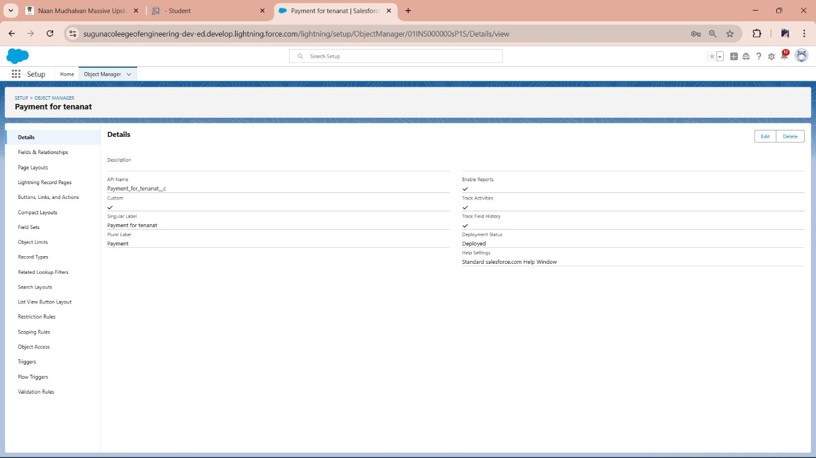

# Create Lease Object

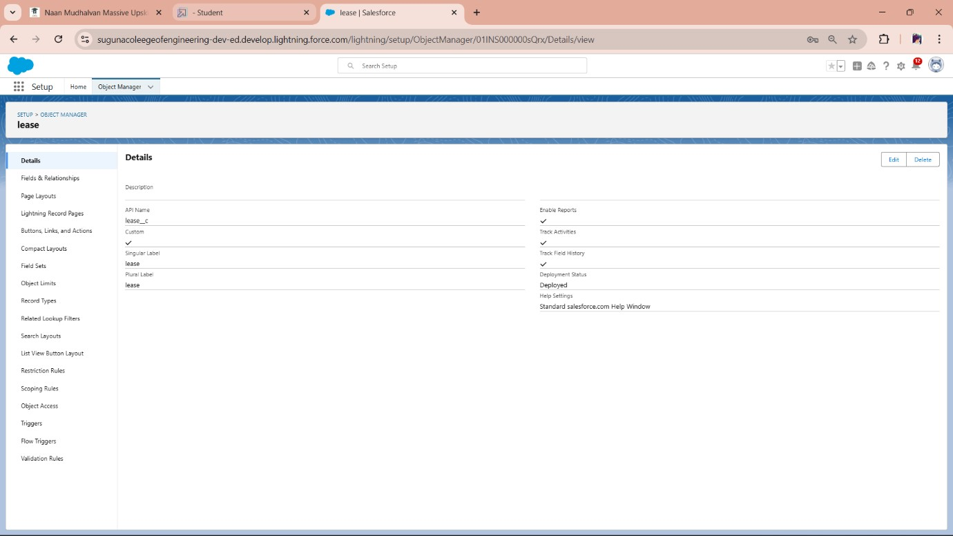

# Tabs Creating a Custom Tab

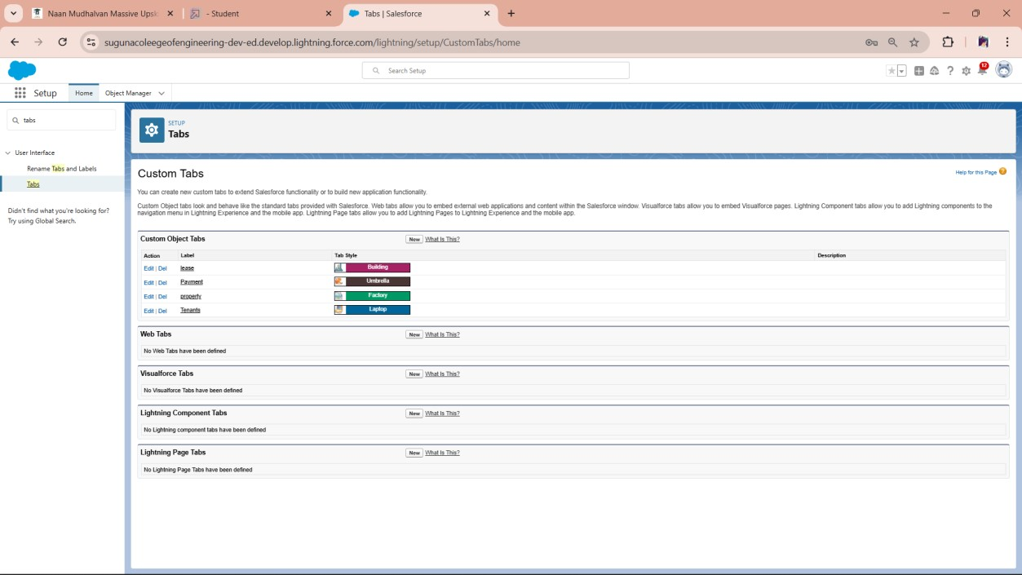

# The Lightning App Create a Lightning App

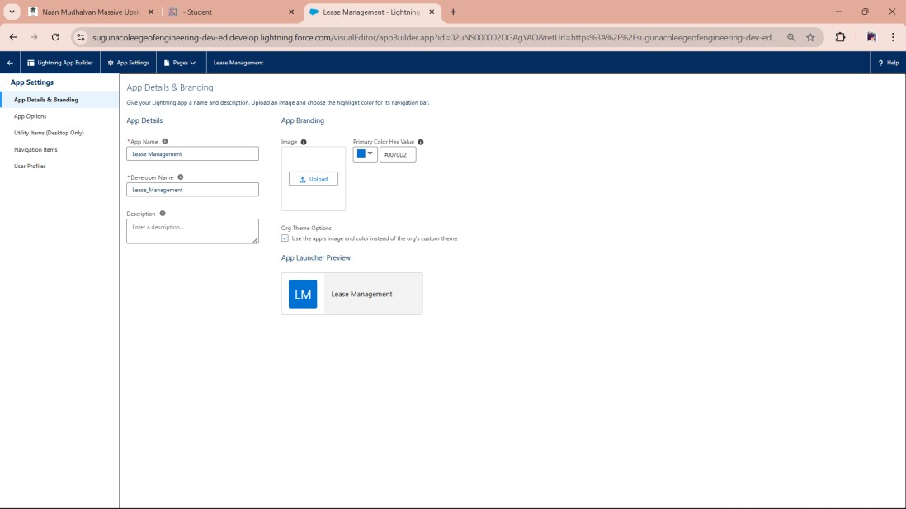

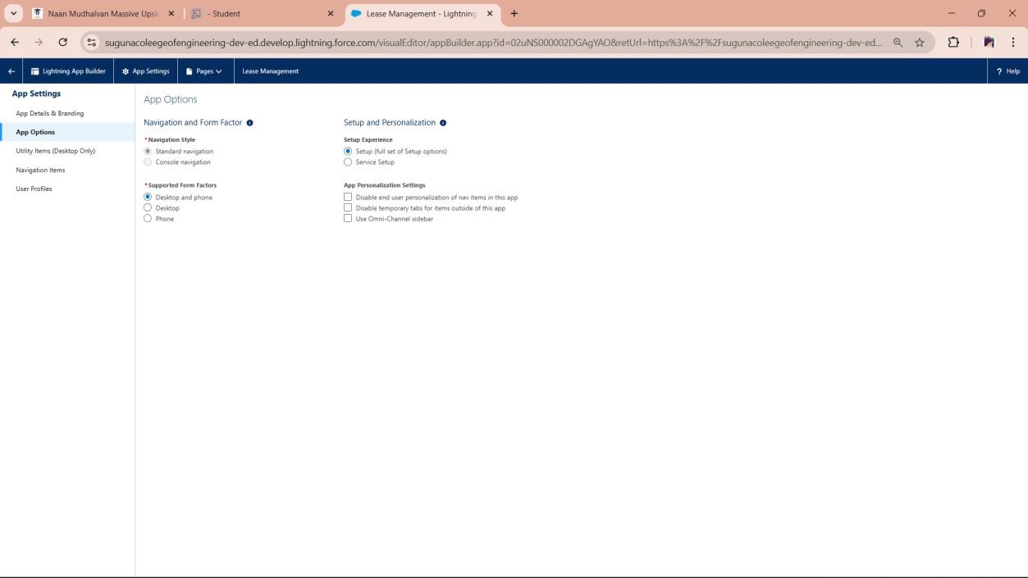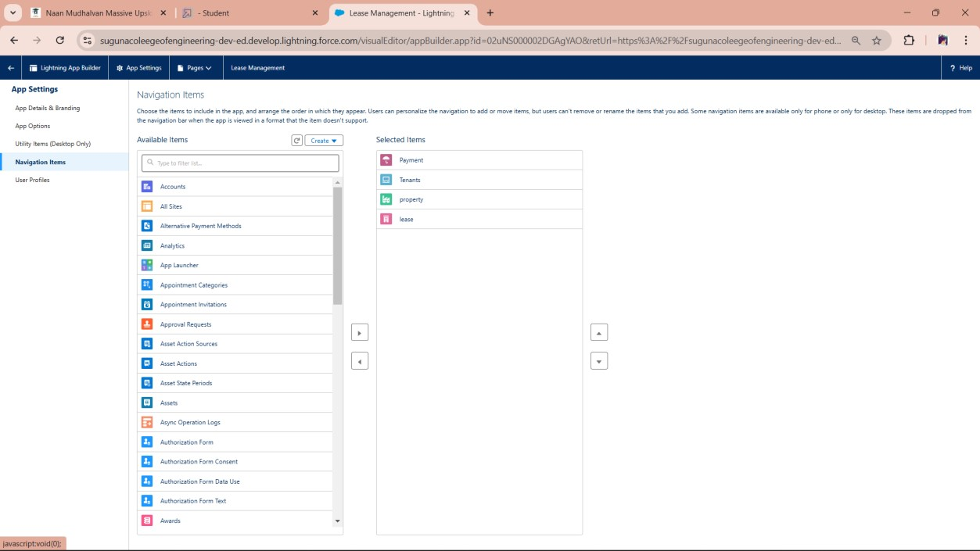

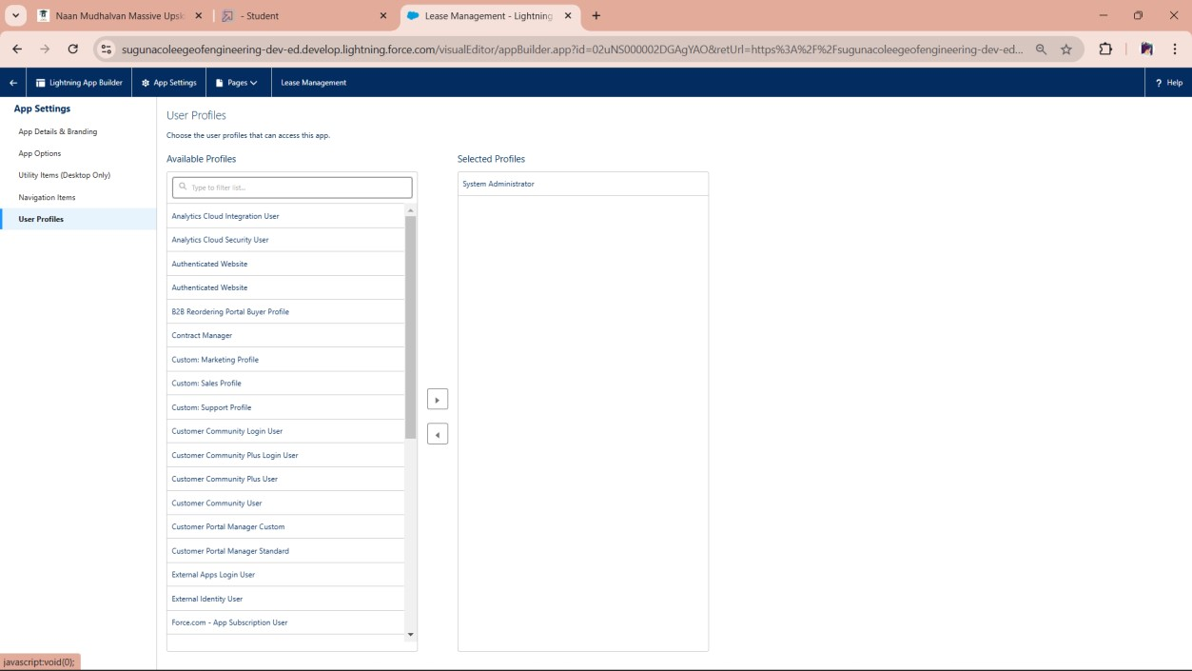

# Fields Creation of fields for the property object

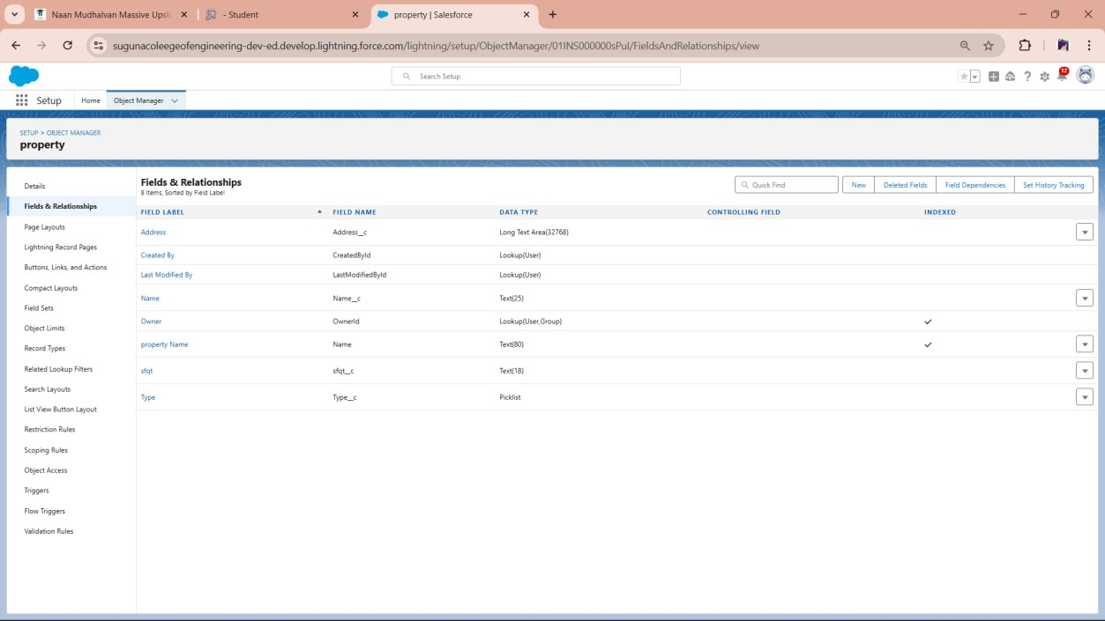

# Creation of fields for the Tenant object

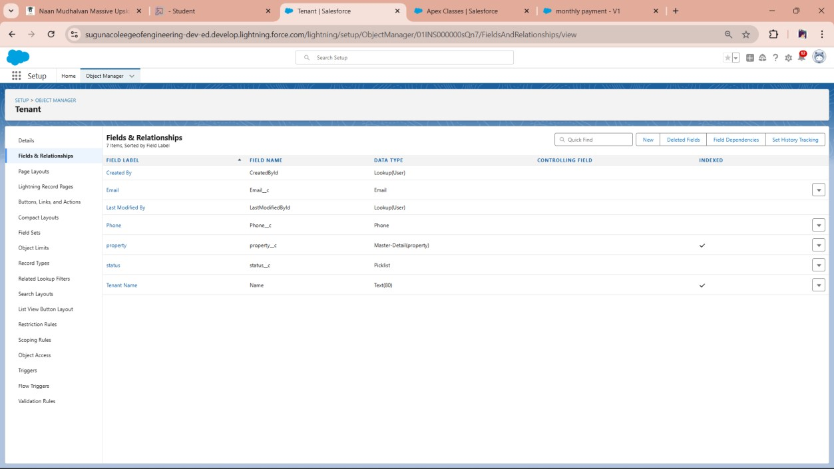

# Creation of fields for the Lease object

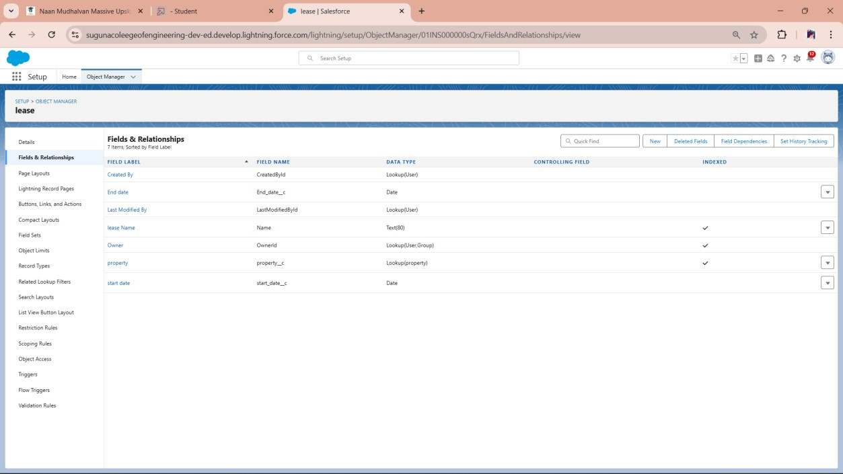

# Creation of fields for the Payment for tenant object

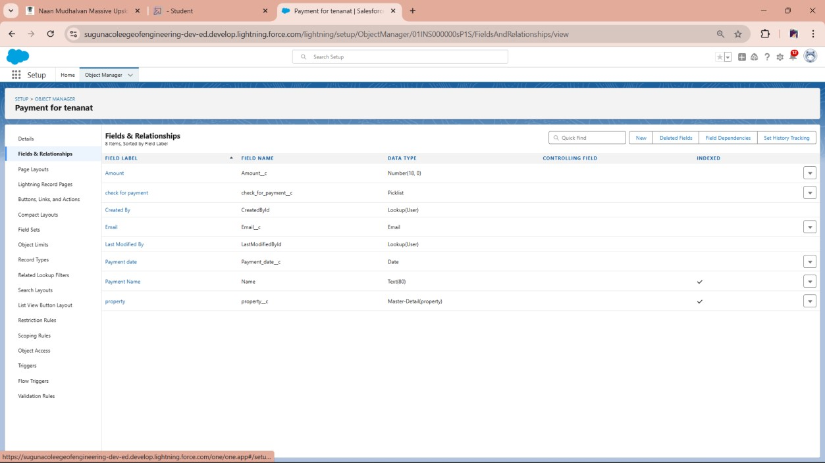

# Validation rule

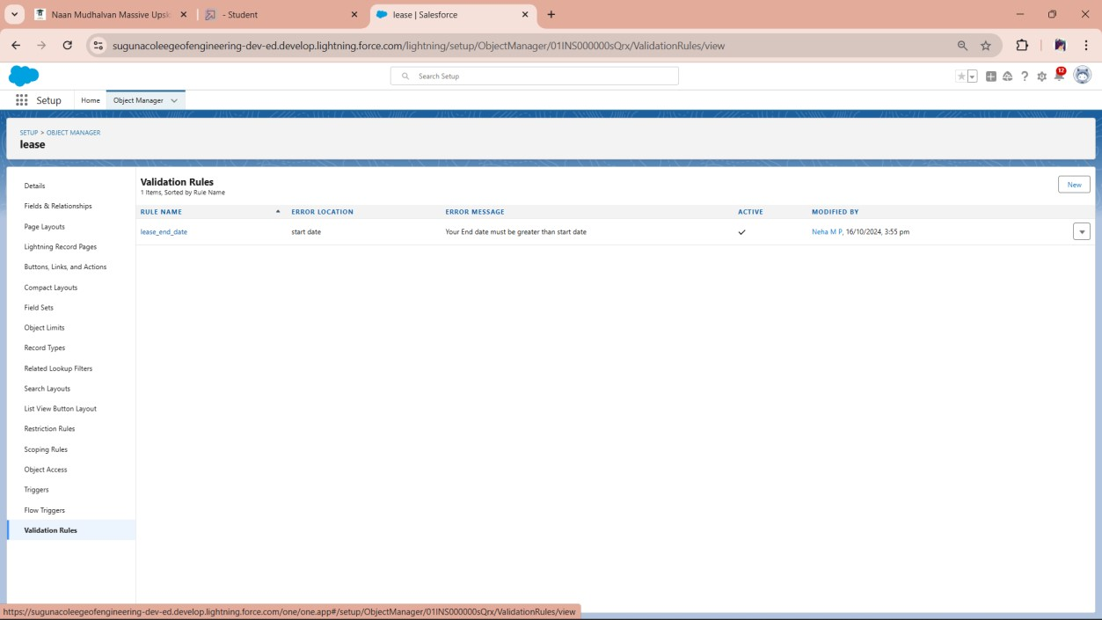

# Create Email Template For Tenant Leaving

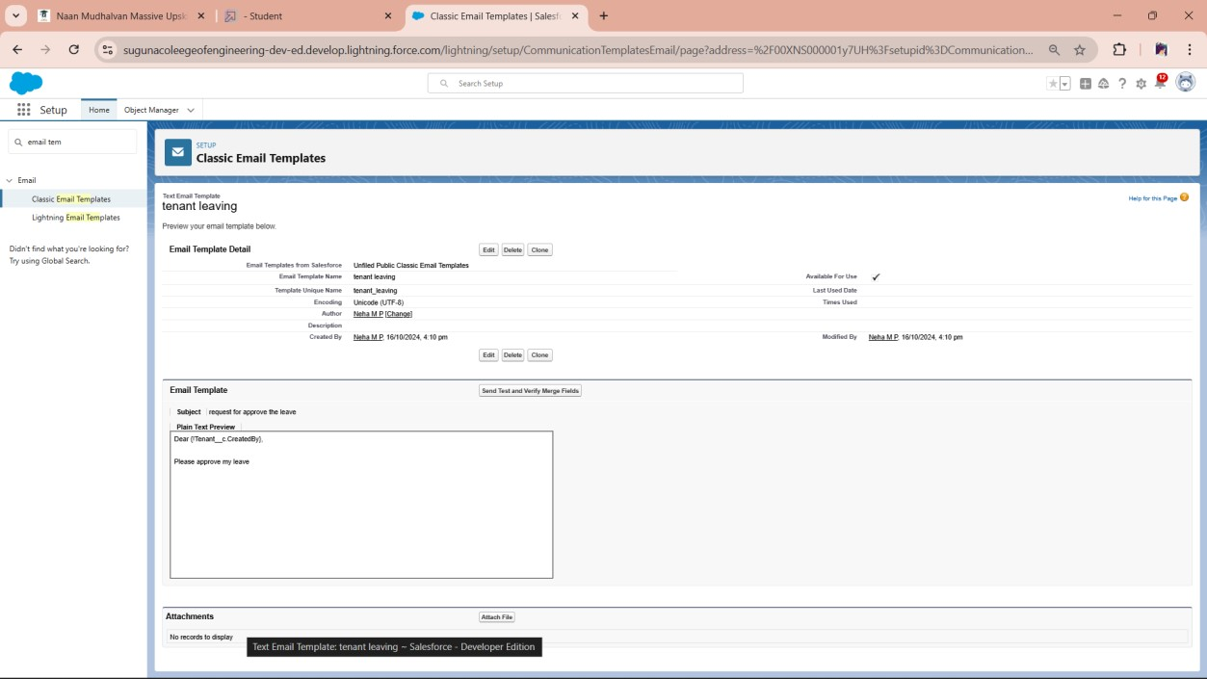

# Create Email Template For Leave Approved

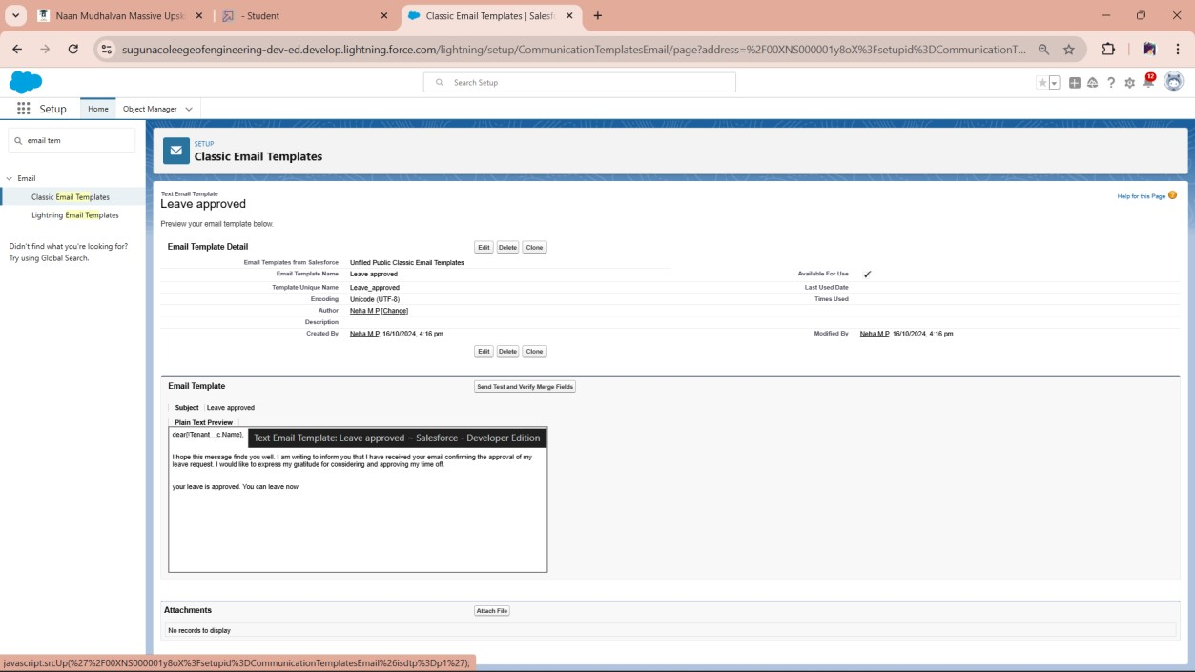

# Create Email Template For rejection for leave

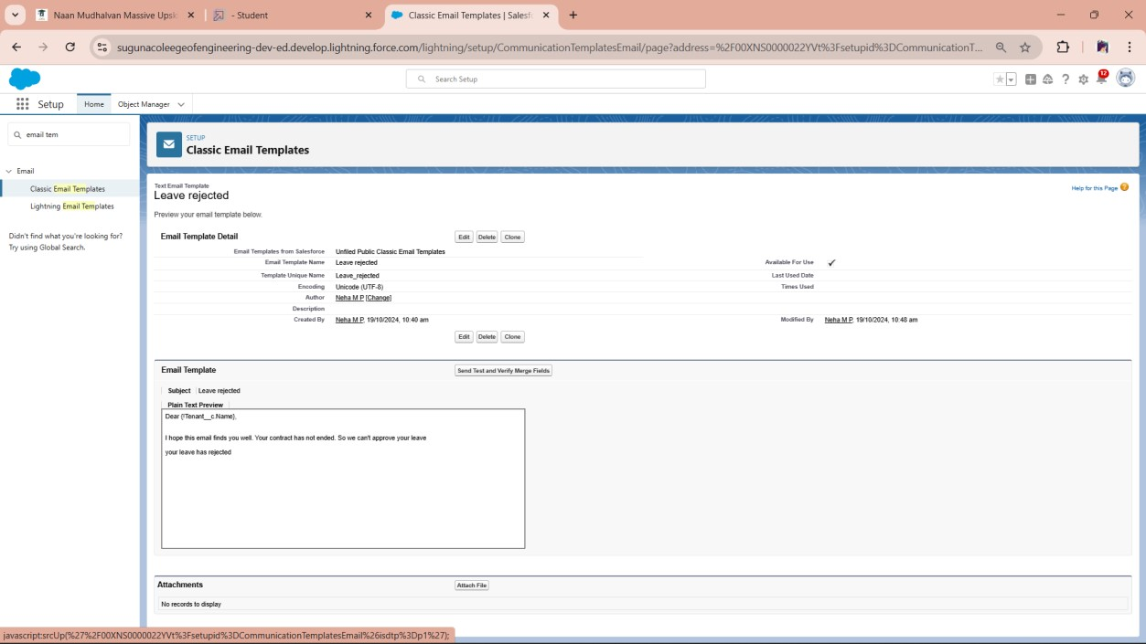

# Create Email Template For Monthly payment

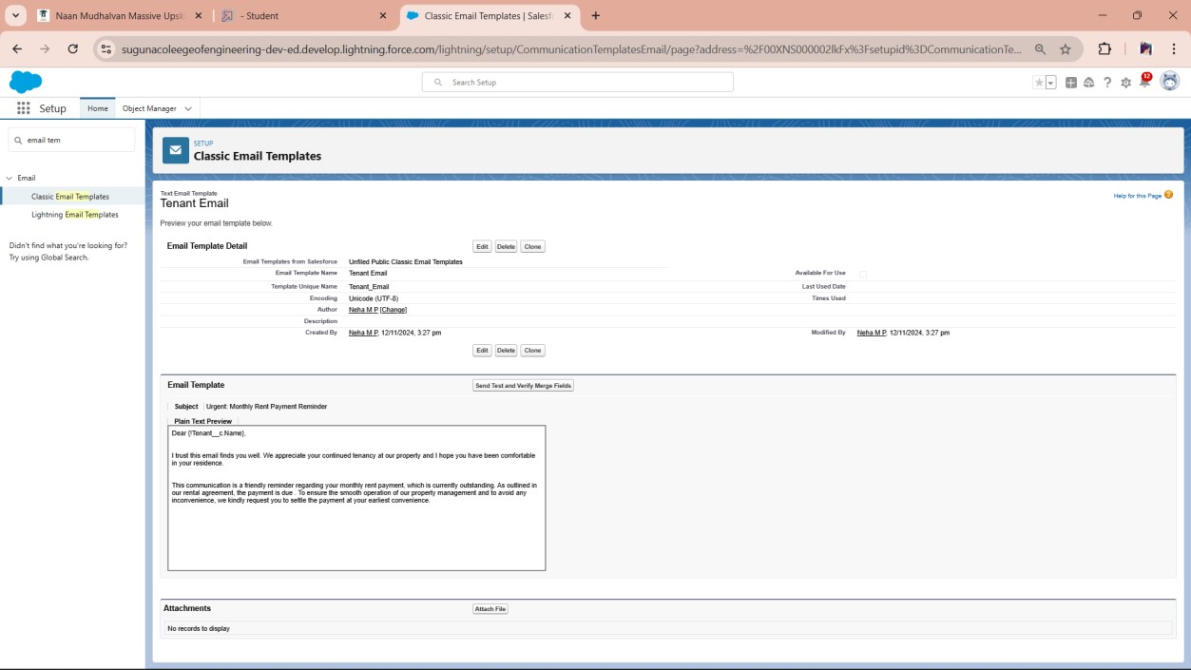

# Create Email Template For successful payment

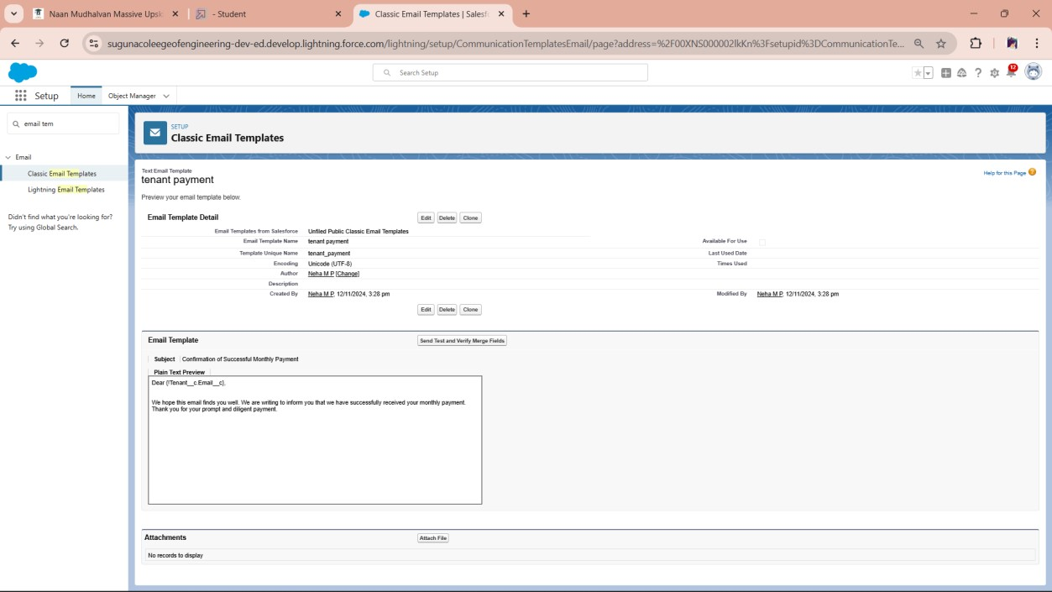

# Approval Process

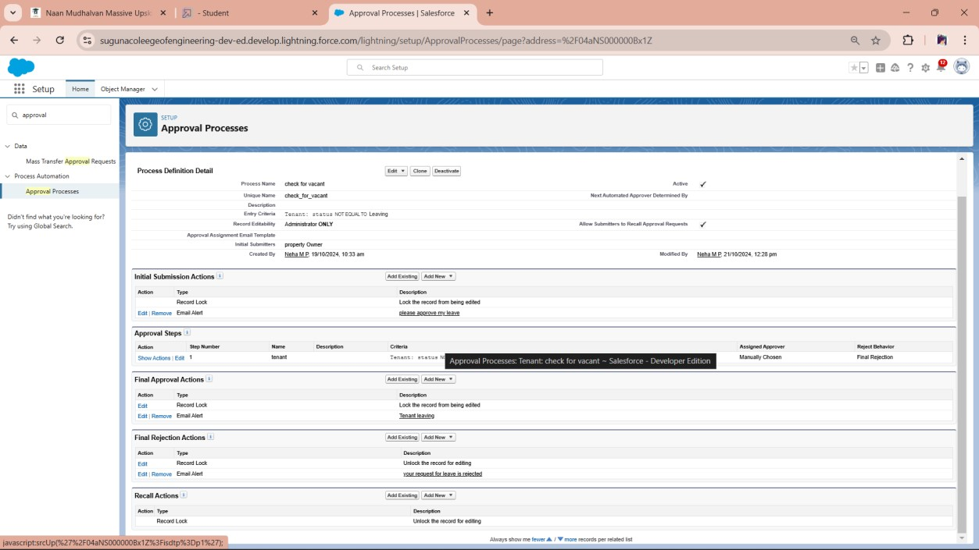

**Apex Trigger**

# Testing the Trigger

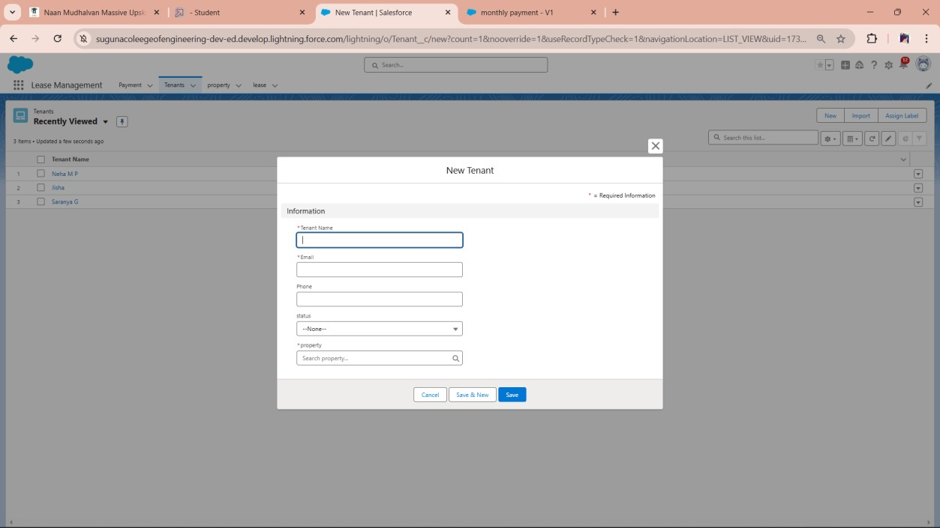

# FLOWS Create Flow for monthly payment

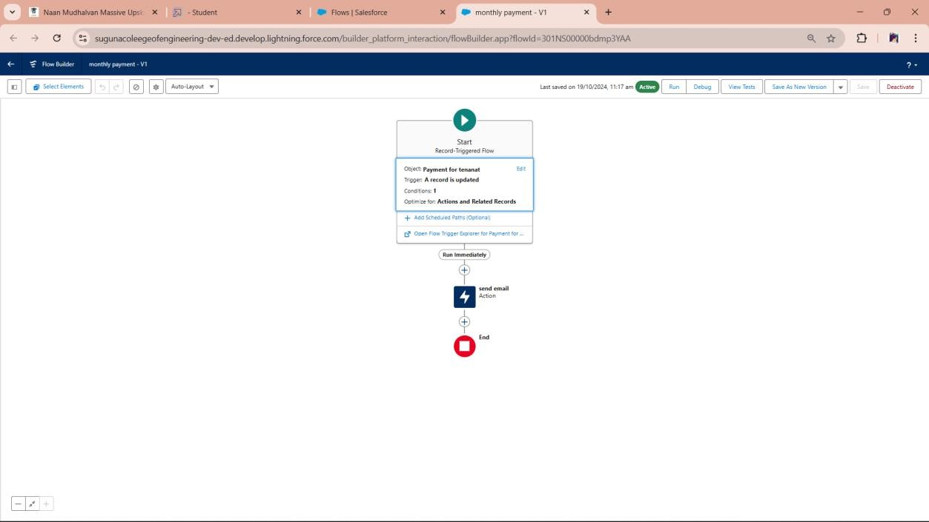

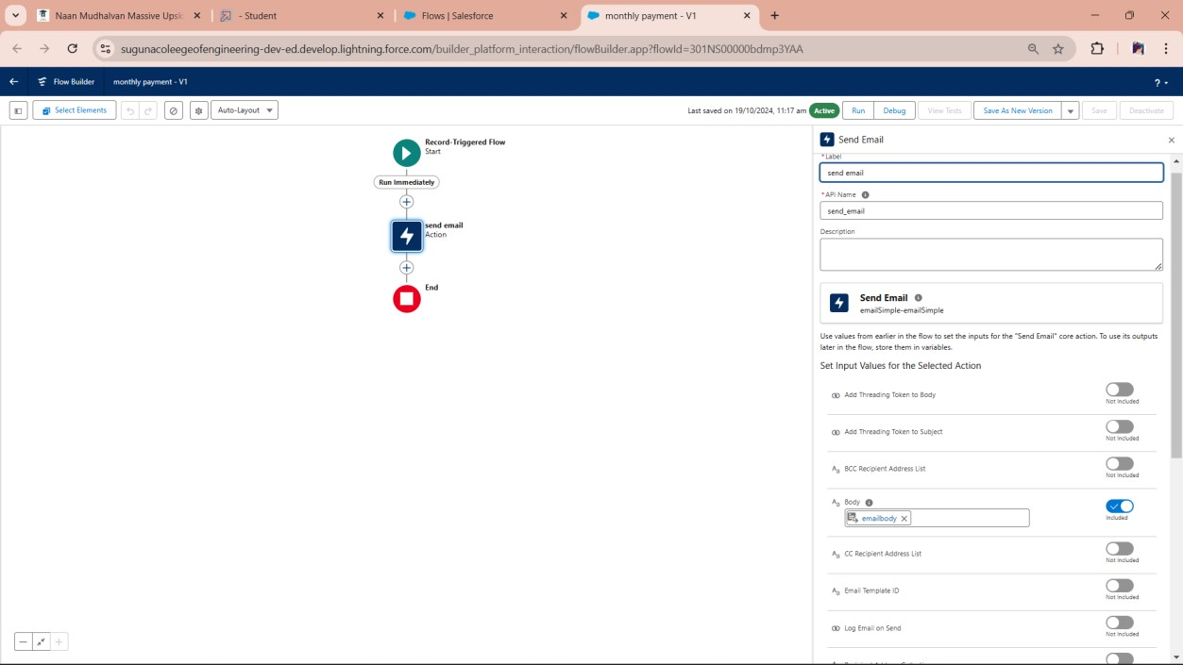

**Schedule class :**

